# INFA723 Cryptography and Network Security

# Lab 1 Set up OpenSSL Testing Environment

(Optional if you already have an OpenSSL Testing Environment)

# 1 Introduction

The labs are based on OpenSSL command line. To continue the lab, you need to set up your own OpenSSL testing environment. If you already have an OpenSSL testing environment on your computer, you can skip this lab. There are two options to set up the OpenSSL testing environment. You can choose either of the two options:

* Option 1: Set up a Kali Linux testing environment using VMWare Workstation Player
* Option 2: Use a Linux virtual machine in the DSU IA lab.

Section 2 lists the steps for set up a Kali Linux testing environment using VMWare. If you prefer to use a Linux virtual machine in the IA lab, please contact with me (yong.wang@dsu.edu).

# 2 Set up a Kali Linux testing environment using VMWare

(**The steps listed below are for reference only. Please use the latest software release to build your testing environment.**)

The following software are need for the lab:

* **VMWare Workstation Player for Windows**: VMware Workstation Player is used.
  + Download Links: https://my.vmware.com/web/vmware/free#desktop_end_user_computing/vmware_workstation_player/14_0
* **Kali Linux VMWare Image**: Kali Linux is used. The Kali Linux VMware image is about 3GB. It may take a while to download it.
  + **Download Links**: https://www.offensive-security.com/kali-linux-vm-vmware-virtualbox-hyperv-image-download/

We assume you download all the necessary software to C:\temp directory.

A host windows machine will be used to set up the testing environment. Make sure you are consistent when choosing the software to be installed. For example, choose 32-bit Kali Linux for 32-bit Windows, choose 64-bit Kali Linux for 64-bit Windows, etc.

There are many different ways to set up Kali Linux in the virtual environment. In this lab, we demonstrate how to set up Kali Linux using a Kali Linux VMWare image. If you want to install Kali Linux from ISO file, or using Oracle VirtualBox, refer to the guidance in the useful link session.

The setup install two steps, i.e., install VMware Workstation Player and install Kali Linux.

## Install VMware Workstation Player

The installation guideline is demonstrated using the VMware-player-6.0.3-1895310.exe. Use the latest version you have downloaded to replace VMware-player-6.0.3-1895310.exe in the following installation proedure.

1. go to C:\temp directory and double click VMware installation pacakge (e.g, VMware-player-6.0.3-1895310.exe);

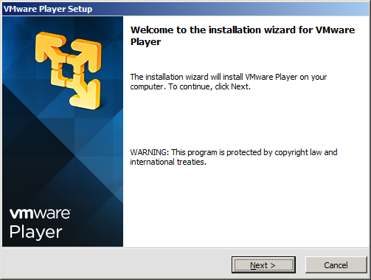

1. Click Next, accept the license agreement and choose the destination folder for your installation;

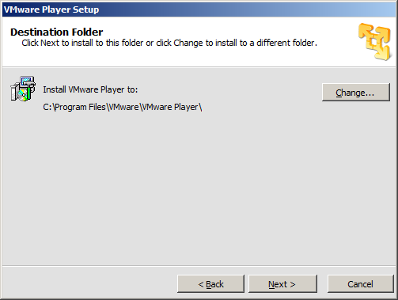

1. Click Next and choose your installation options until the installation process begins:

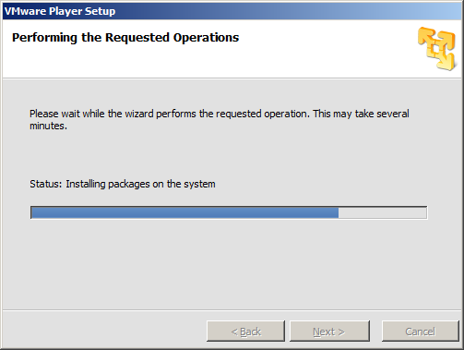

1. Click Finish to complete the setup.

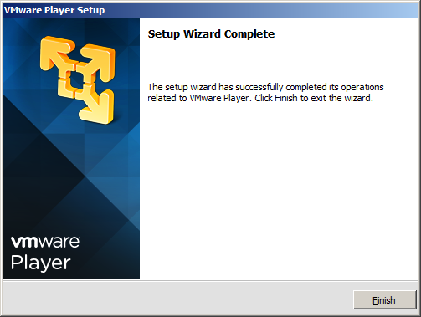

## Install Kali Linux

The installation guideline is demonstrated using the kali-linux-1.0.9-vm-i486.7z. Use the latest version you have downloaded to replace kali-linux-1.0.9-vm-i486.7z in the following installation proedure.

1. Go to C:\temp directory and extract the vmware image (e.g. kali-linux-1.0.9-vm-i486.7z) to C:\ kali-linux-1.0.9-vm-i486 directory (or a destination folder you choose.)
2. Start VMWare Player;

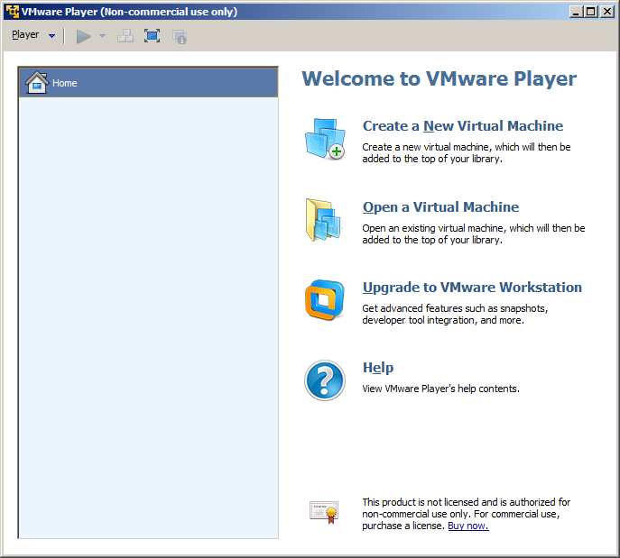

1. Click Open a Virtual Machine and go to C:\Kali-Linux-1.0.9-vm-486 folder:

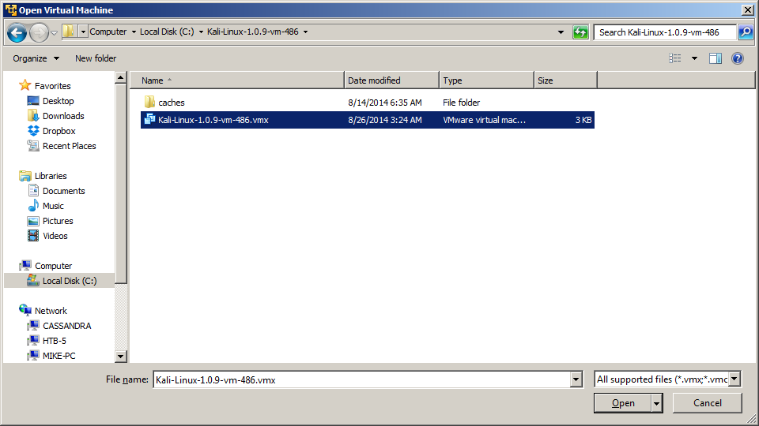

1. Select “Kali-Linux-1.0.9-vm-486.vmx” and click Open;
2. Kali-Linux-1.0.9-vm-486 will be added to your VMPlayer:

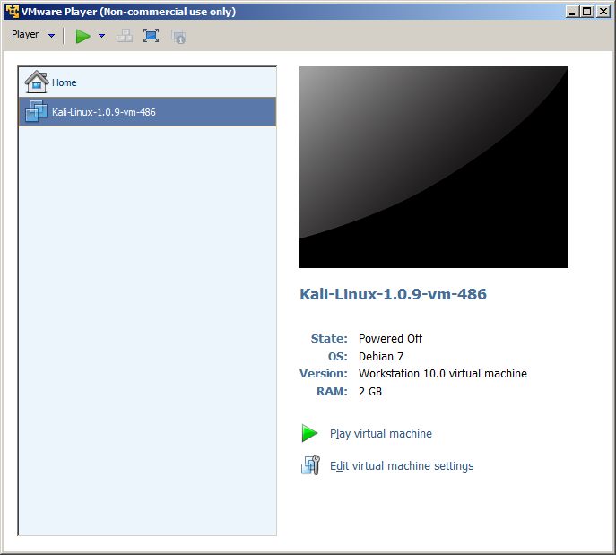

1. Select “Kali-Linux-1.0.9-vm-486” in the VMPlayer and click “Play virtual machine”;
2. Click “I copied it” if a window pop out and ask if the virtual machine has been moved,

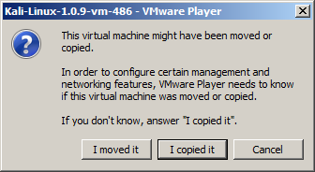

1. Click “OK” or “Remind Me Later” to skip installing the Removable Devices and updating VMware.

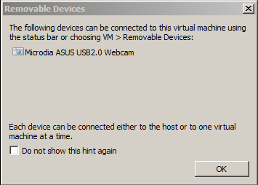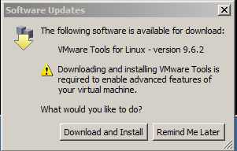

1. For the 32-bit installation, you may encounter a warning message for compatibility with 64-bit applications, click “OK”.

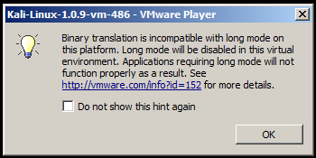

1. The first book up may take a minute. A booting up window is shown below:

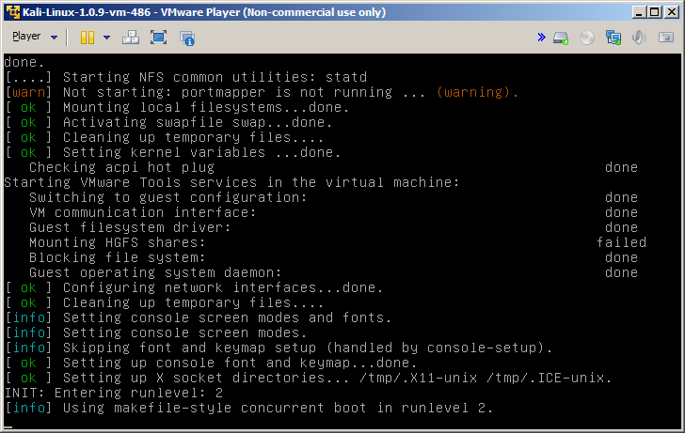

1. In the end the booting process, a login window will pop up.

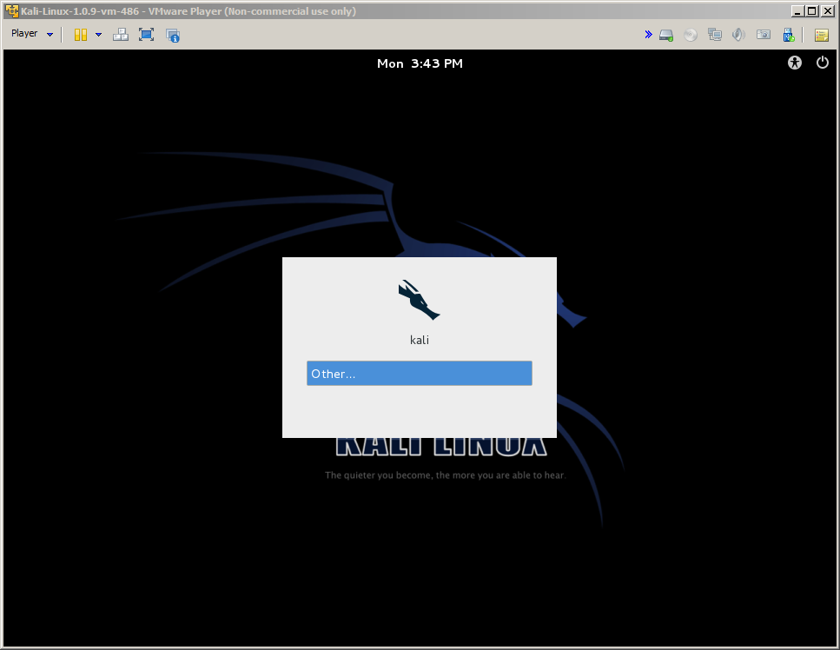

1. The default user name is root. The default password is toor. Enter you username and password and login to Kali Linux.

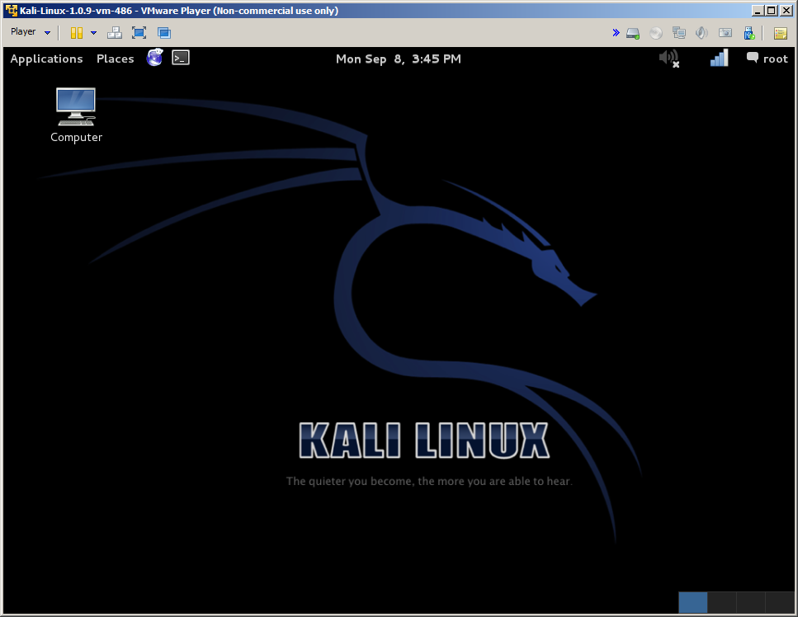

# 4 Useful Links

1. Complete guide on how to install Kali Linux (ISO) in Vmware: <http://lewiscomputerhowto.blogspot.com/2014/01/complete-guide-on-how-to-install-kali.html>
2. A detailed guide on installing Kali Linux on VirtualBox: <http://www.blackmoreops.com/2014/04/08/detailed-guide-installing-kali-linux-on-virtualbox/>